Physics 1 Unit 3 – Forces Name: ___________________________

IB 2.2 Forces - More practice

1. A 15,000 kg helicopter is lifting a 4500 kg truck with an upward acceleration of 1.4 m/s2. Calculate a) the force the air exerts on the helicopter blades and b) the tension in the supporting cable for the truck.
2. A 5.00 kg block is pulled along a horizontal frictionless floor by a cord with a tension of 12.0 N at an angle of 25.0° above the horizontal. a) What is the acceleration of the block? b) The tension is slowly increased. What is its value just before the block is lifted (completely) off the floor? c) What is the acceleration of the block just before it is lifted (completely off the floor? d) Answer a) – c) if instead the coefficient of dynamic friction between the block and the floor is 0.19.
3. A 49 kg rock climber is climbing a “chimney” between two rock cliffs. The static coefficient of friction between her shoes and the rock is 1.2. Between her back and the rock it is 0.80. As she tired, she reduced her push against the rock until her back and her shoes are on the verge of slipping. a) What is her push against the rock? b) What percent of her weight is supported by the frictional force on her shoes?

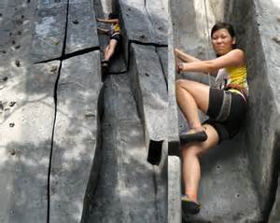

1. A student, crazy with final exams, uses a force, F of magnitude 80 N at a 70 angle to the horizontal to push a 5.0 kg block across the ceiling of his room. If the coefficient of dynamic friction between the block and the ceiling is 0.40, what is the magnitude of the acceleration of the block?

